**Nobag Completed parts Part 2**

Fourth and last role is tourist role.

So,

* **Tourist Role:** To access tourist panel there is button on home page with “Login” title as shown in below image:

**GUIDE-PANEL**

When user click on login button then page appears like this.

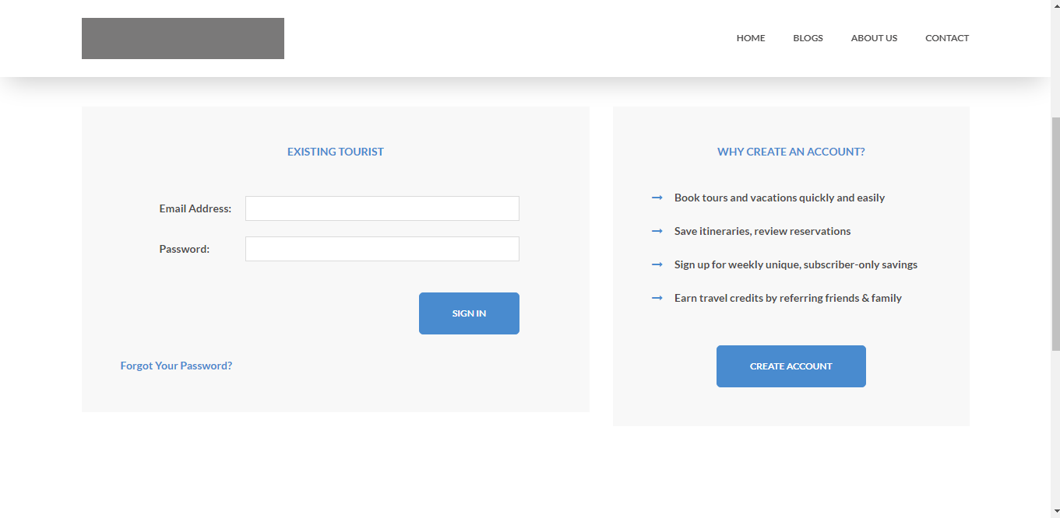

So just like guide login page there are also two sections on for “EXISTING TOURIST” and other for to create new account so in that section we easily see a button to create account when tourist click on that button a page appears.

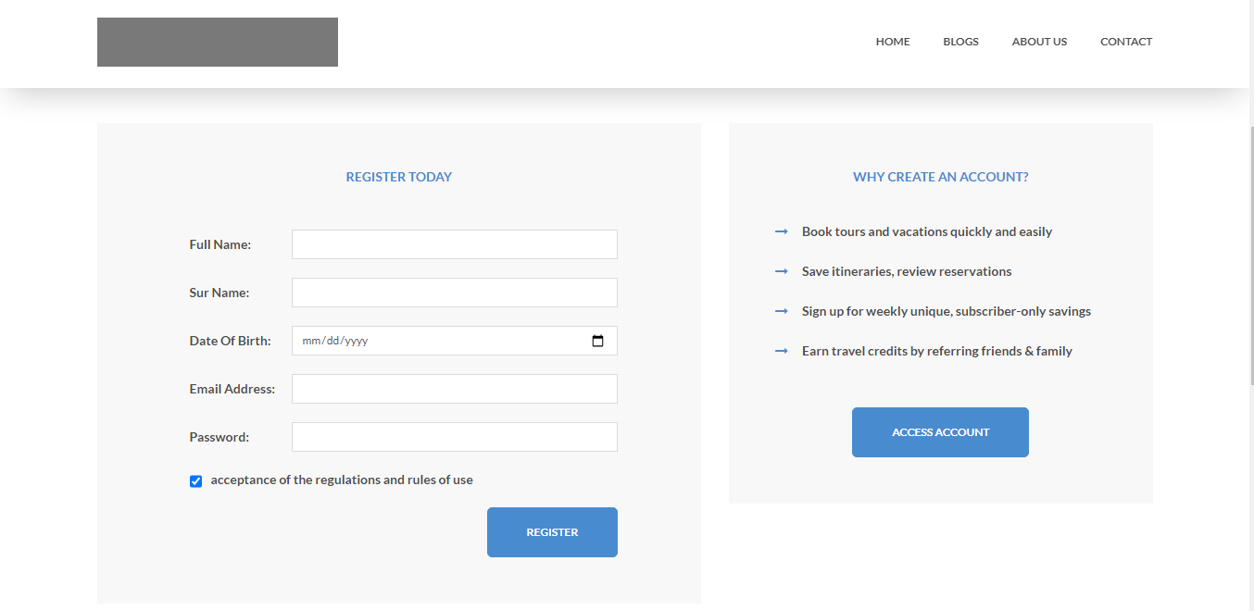

So in this page tourist register himself as tourist by saving this form according to client requirements.

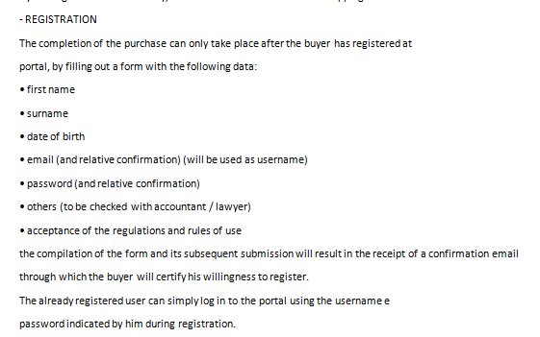

Sp according to client above tourist provide his basic information and register himself/herself on our platform and when tourist register himself/herself then a message appears on screen that he must have to verify his email address according to above mention requirements an email sent to his/her email automatically by system which confirmation link when tourist confirm his/her email then he able to login.

So after login with his credentials like these ones

Username: [m.awan.saifurrehman@gmail.com](mailto:m.awan.saifurrehman@gmail.com)

Password: password

So on clicking login button a tourist redirects to his panel home page which look like this.

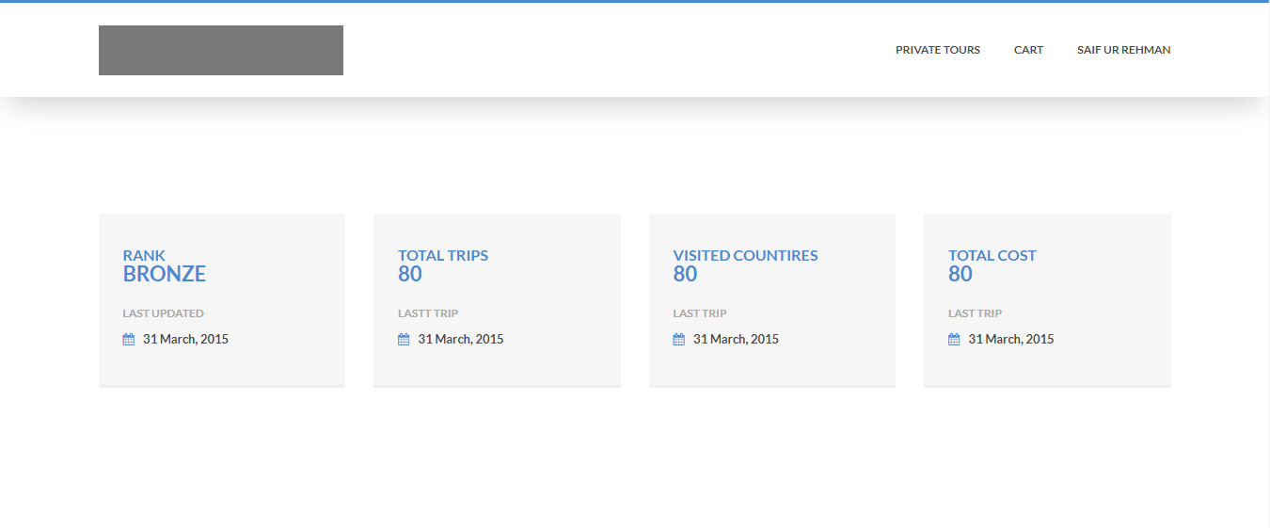

Here tourist see his/her history like his rank total trips which he take total countries which he/she visited and total cost which he spend.

And on top of this page he/she able to see menu bar with three option one is Tours and other are cart and tourist name on right side. When tourist hover his mouse on his/her name a dropdown appears with two buttons one for profile and other for logout. On clicking logout button his session is removed and he/she redirected back to home screen and on clicking profile button his profile page appears.

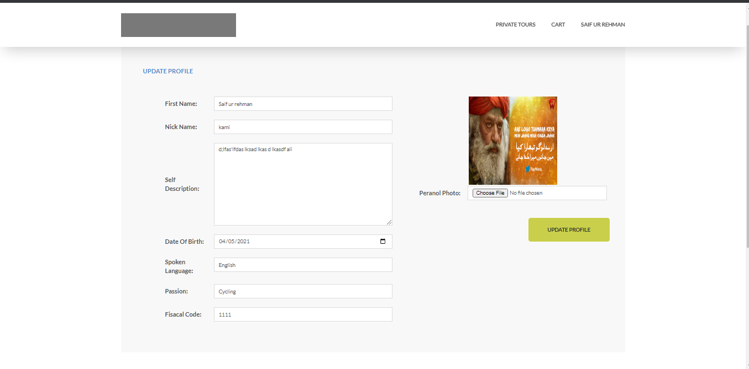

So here tourist add update his profile according to client requirements.

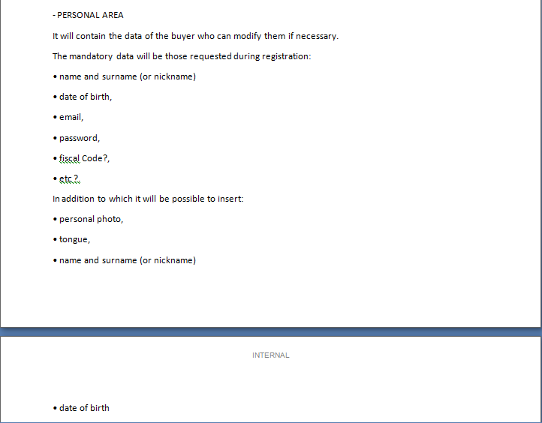

So according to above requirements tourist update add his/her profile.

* **Home Page**: In home page someparts are dynamic and some or with their dummy data.

**Top Menu bar**:



In this above image this is menu bar from which one is nobag logo on left side which is dummy at that moment and on right side there four more buttons Home, Blogs, about us and contact us page.

On clicking home button you are redirected to home page and on clicking blog button a page appears

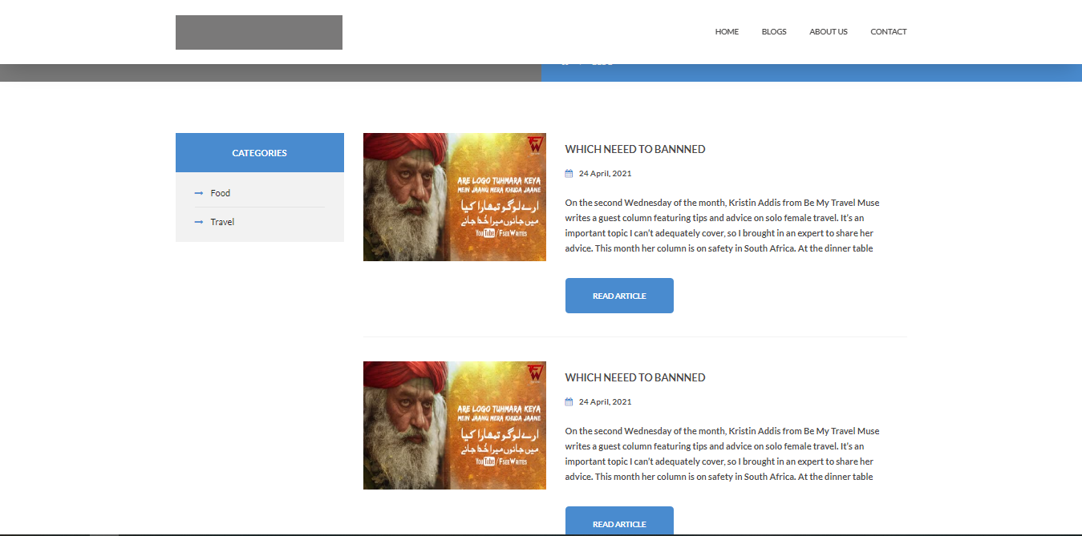

Here on this page all blogs are shown and on their lift side there is categories section which contains all categories which are added by editor. Which we see in part 1 of document. This page is dynamic all blogs and categories are coming from backend.

**About**: when user clicks on that button a page appears with team profile which is added by admin.

**Contact:** On clicking this a page appears with form where user fill forms and send his message which are shown on admin and editors panels and also email sent to user email with message that we nobag team received his/her message.

* **Article Section:** article section the article which are shown are all dynamic and this are those articles(blogs) which are added by guides and on clicking these articles “read more” button a new page appears

**Article Section in home page**:

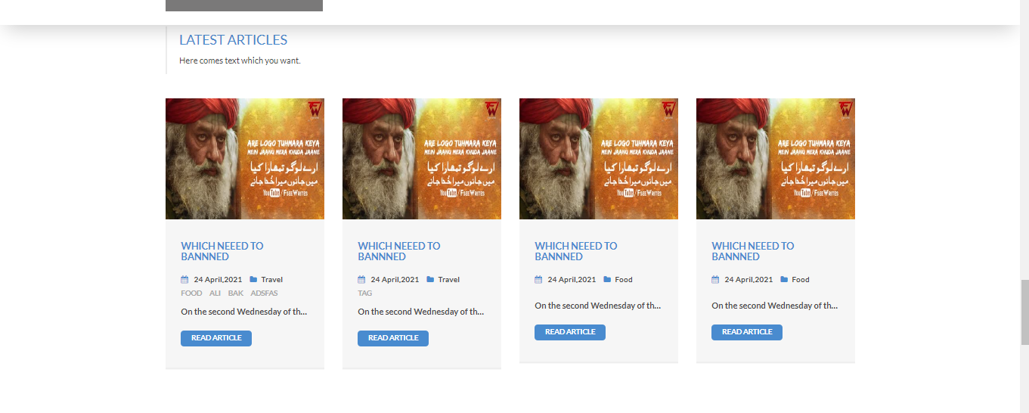

These are four latest articles which are automatically shown by platform according to there publishing time.

And Footer section on home page and all other pages are also with some dynamic data like

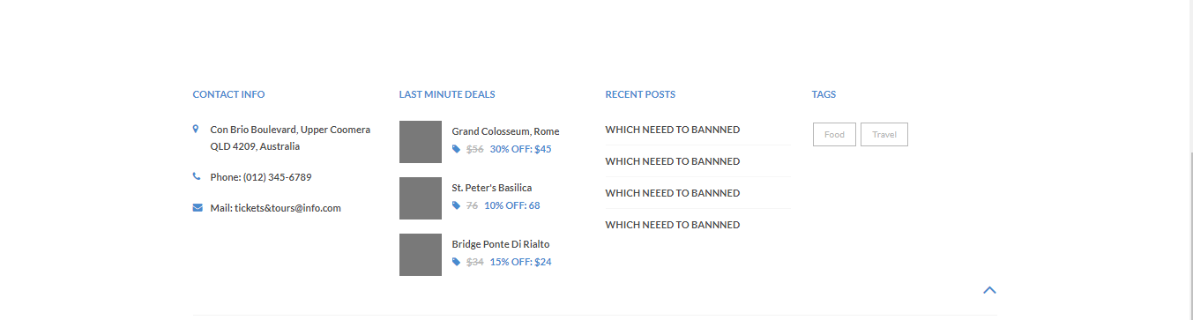

Here recent post and tags section are dynamic and these are coming form backend,

**Note:**

**All above mentioned things are done according to client requirements and some are added by us which are necessary. And not mentioned by client. We are hoping that you like and appreciate our effort.**

**Thanks.**